1. - You start with $1000 initial money

- For each round, you play until you run out of money or for 10 games.

- Run simulations for 10 such rounds and report your results by filling the table below:

Do you think this system works? Explain in 1-2 sentences.

What to turn in:

- Your code in R or any other language. If you use another language, you would need to write

the craps code in that language.

- The table as shown above and your explanation (It can be in a txt file, Word doc, or PDF)

|  |  |  |
| --- | --- | --- |
| Round | Ending Amount | Number Of Games Played |
| 1. | -200 | 5 |
| 2. | -700 | 8 |
| 3. | 800 | 10 |
| 4. | -500 | 5 |
| 5. | -600 | 9 |
| 6. | 600 | 10 |
| 7. | 800 | 10 |
| 8. | -400 | 3 |
| 9. | 0 | 9 |
| 10. | -500 | 5 |

**I don’t think this system works, as every time you run this function the system will result in a different answer. Thus, there wouldn’t be a fixed model to make a machine learning algorithm for this system.**

**CODE –**

myfunc <- function(){

bal = 1000

bet = 100

games = 1

cat('games_no')

cat(' ')

cat('result')

cat(' ')

cat('bet_amount')

cat(' ')

cat('net_bal\n')

while(bal>0 && games < 11)

{

x <- craps()

if(x==0) {

cat(games)

cat(' ')

cat('loose')

cat(' ')

cat(bet)

cat(' ')

bet = bet*2

bal = bal - bet

cat(bal)

cat('\n')

}

else{

cat(games)

cat(' ')

cat('win')

cat(' ')

cat(bet)

cat(' ')

bet = 100

bal = bal + bet

cat(bal)

cat('\n')

}

games = games+1

}

}

2. a. Using the quantmod package in R, download the price data for the following stock symbols

starting from 1st Jan 2000 to present.

- DJIA (Dow Jones Industrial Average) ,- SPY (S&P 500), - AAPL (Apple Corp),- BAC (Bank of America),- NFLX (Netflix),- PCLN (Priceline),- AMZN (Amazon)

b. Plot the chart for each of the the stocks and overlay the value of Simple Moving Average 200

i.e. SMA(200). Include the plots in your report.

Code Used :

#load.packages('curl', repos = 'http://cran.r-project.org')

library(quantmod)

getSymbols("DJIA", src = "yahoo", from = '2000-01-01',warnings = FALSE)

chartSeries(DJIA,theme = chartTheme("black", up.col='gold'),type = 'line')

addSMA(200)

getSymbols("SPY", src = "yahoo", from = '2000-01-01',warnings = FALSE)

chartSeries(SPY,theme = chartTheme("black", up.col='gold'),type = 'line')

addSMA(200)

getSymbols("AAPL", src = "yahoo", from = '2000-01-01',warnings = FALSE)

chartSeries(AAPL,theme = chartTheme("black", up.col='gold'),type = 'line')

addSMA(200)

getSymbols("BAC", src = "yahoo", from = '2000-01-01',warnings = FALSE)

chartSeries(BAC,theme = chartTheme("black", up.col='gold'),type = 'line')

addSMA(200)

getSymbols("NFLX", src = "yahoo", from = '2000-01-01',warnings = FALSE)

chartSeries(NFLX,theme = chartTheme("black", up.col='gold'),type = 'line')

addSMA(200)

getSymbols("PCLN", src = "yahoo", from = '2000-01-01',warnings = FALSE)

chartSeries(PCLN,theme = chartTheme("black", up.col='gold'),type = 'line')

addSMA(200)

getSymbols("AMZN", src = "yahoo", from = '2000-01-01',warnings = FALSE)

chartSeries(AMZN,theme = chartTheme("black", up.col='gold'),type = 'line')

addSMA(200)

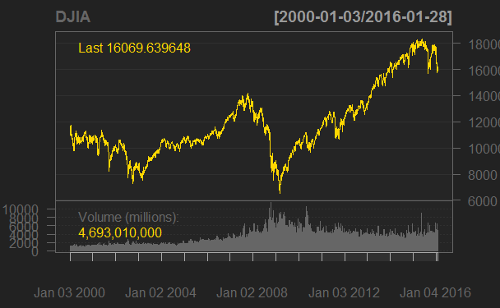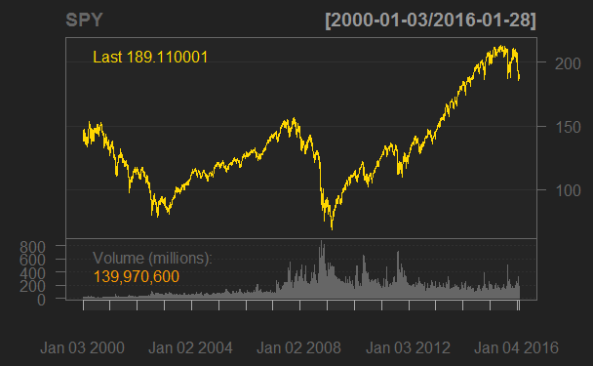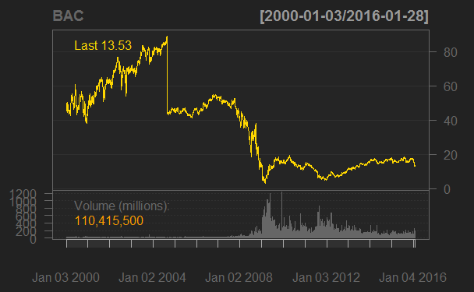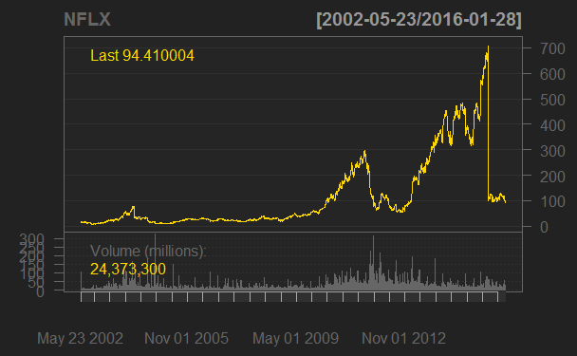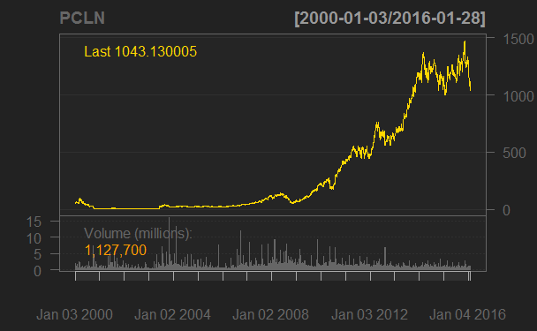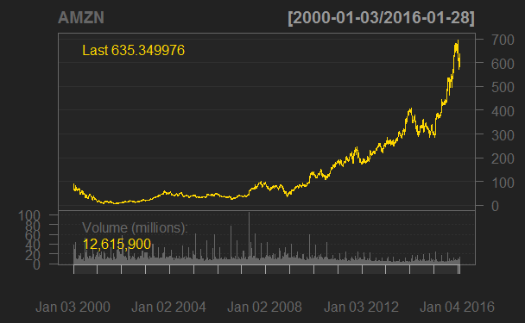

c. In this last part, you will use the SIT toolbox to compare the above-mentioned trading strategies

– Buy Hold and SMA Crossover. The code in R for this is provided in the file trading.R. Be sure to

install the required packages by uncommenting the top lines and also change the stock symbols.

|  |  |  |  |  |  |  |
| --- | --- | --- | --- | --- | --- | --- |
| **Stock** | **Buy Hold** | | | **SMA Crossover** | | |
|  | **CAGR** | **Performance** | | **CAGR** | **Performance** | |
| **Best** | **Worst** | **Best** | **Worst** |
| DJIA (Dow Jones Industrial Average) | 2.2 | 11.1 | -7.9 | 1.6 | 3.9 | -3.6 |
| SPY (S&P 500) | 1.6 | 14.5 | -9.8 | 3.7 | 4.4 | -3.9 |
| AAPL (Apple Corp) | -1.1 | 13.9 | -85.5 | 9.1 | 13.2 | -85.5 |
| BAC (Bank of America) | -7.6 | 35.3 | -49.9 | -6.9 | 6.7 | -49.9 |
| NFLX (Netflix) | 13.5 | 42.2 | -86 | 24.3 | 42.2 | -86 |
| PCLN (Priceline) | 20.6 | 494.8 | -42.3 | 23.5 | 494.8 | -39.8 |
| AMZN (Amazon) | 13 | 34.5 | -24.8 | 16.2 | 26.9 | -16.6 |

Figure CAGR Comparision

Figure 2 Worst Performance Comparison

**Conclusions**

* Buy and hold performs better in the long run, as illustrates by the Figure-1 above, we can see that apart from the DJIA all other shares performs gave better Compound annual growth rate(CAGR) in buy-hold mode then the SMA crossover mode.
* Also, Buy and hold helps to eliminate risk as we can see that the worst performance of shares is better in buy-hold compared to SMA crossover as illustrated in Figure-2.

**SPY**

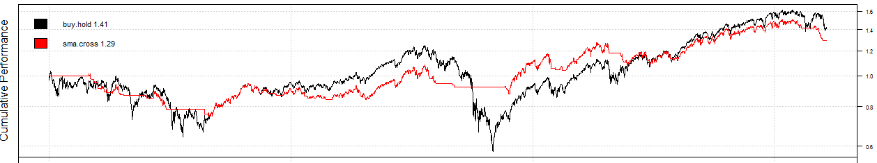

**DGIA**

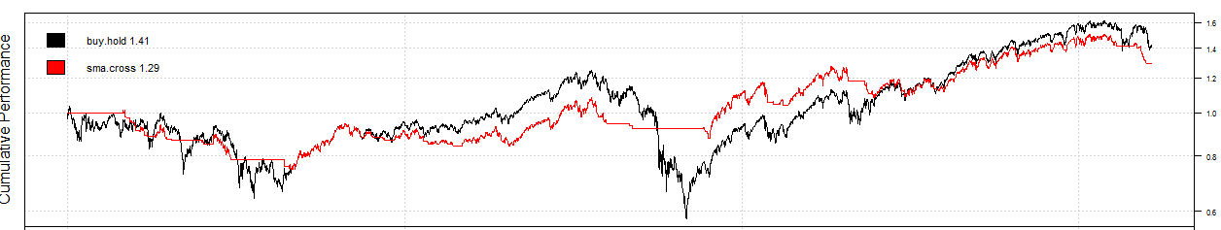

**AAPL**

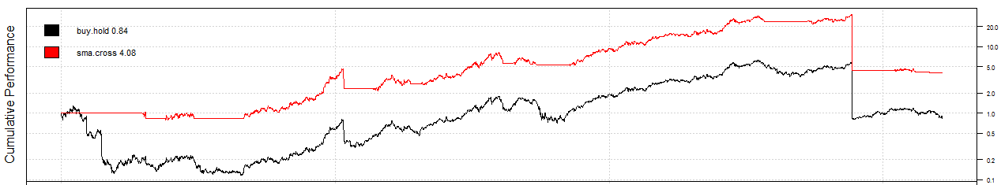

**BAC**

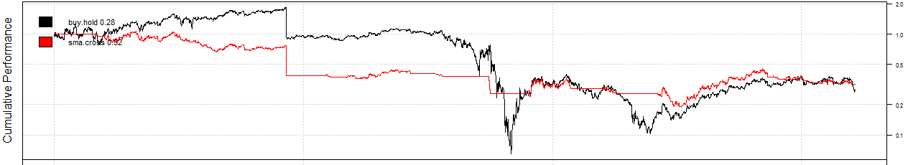

**NFLX**

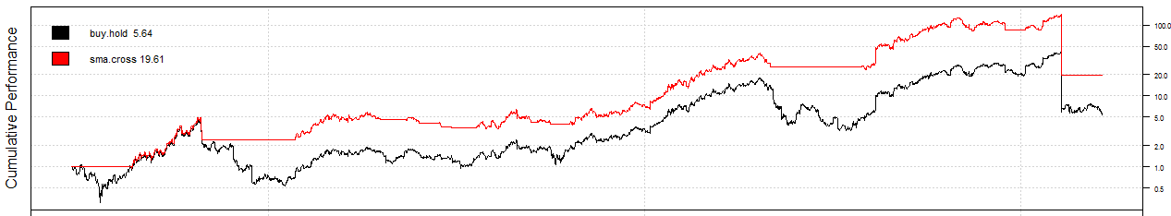

**PCLN**

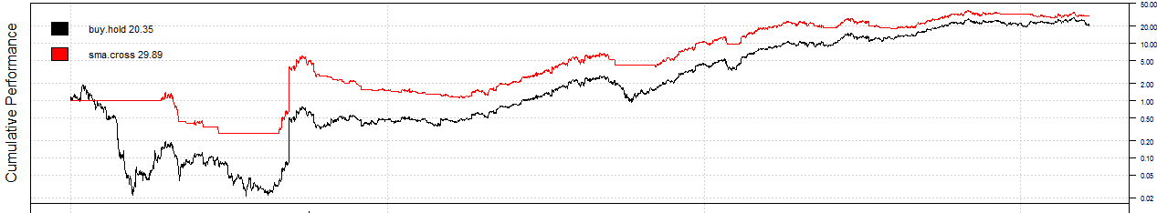

**AMZN**

